**BSCS From Bahria University Islamabad Pakistan**

**Zubair Mushtaq 03436133523**

**Summary**

Hi, Wants to learn and build a lot of things in the field of Datascience.I Have 2.5+ years of experience in Business Intelligence Build 10+ End-To-End BI Projects. Have worked on large Datasets ,Extensively Creates BI Dashbaords, especially in MS Power BI, Tableau and Google Data Studio. Eager to start working in more diverse Data Analytics and Big Data Technolgy.Can Code and lead the Team Effectively.

I have experience in creating professional and informative PowerBI visuals with the help of optimized Data preparation, Data modeling, and complex DAX calculations to bring the company insights beautifully on the Dashboard. Moreover i can do Descriptive Analysis, comparative analysis and predictive analysis on your company's sales Data and Time series forecasting of sales with time intelligence calculations.  
**Portfolio**

Complete portfolio link

https://drive.google.com/drive/folders/1N3BcVn5g2tZbpG2aJFsVSndAvuvgX87I**?**usp=shari  
ng

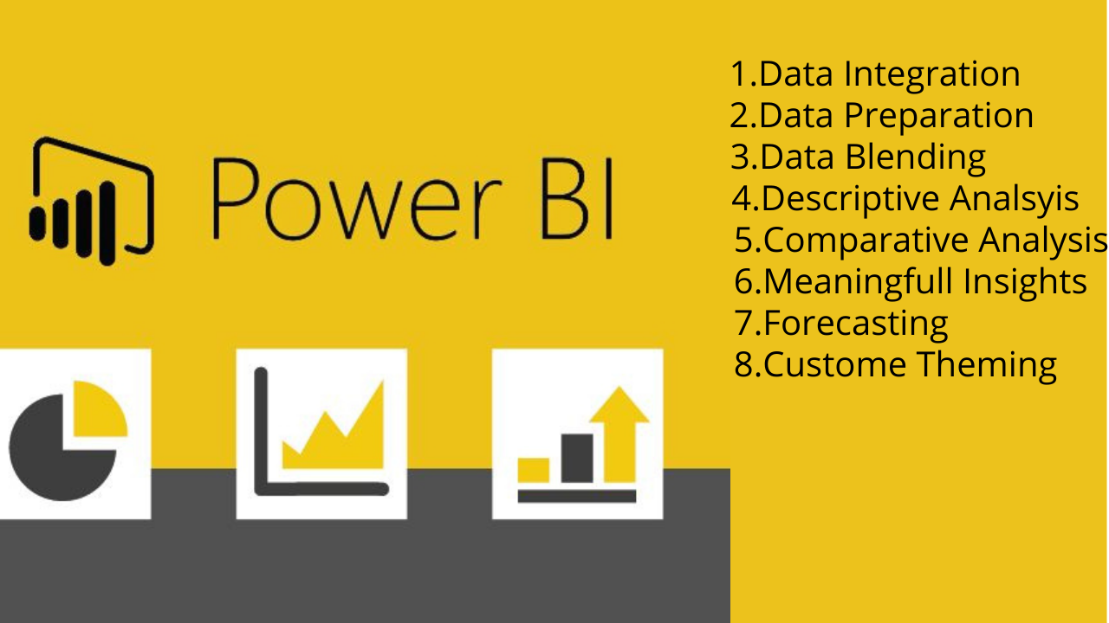

**Below is the Documentation of some of my main projects**

Explanation: This is my fist BI project in XAD technologies Pvt ltd completed in 2 Days timeperiod WHICH HAVE 4 thousands rows and 90 columns, data socures are two seprate excel files first has company project cost and revenue data per Team lead , other has team leads kpis data. there is no primary key in both data sources , moreover the team leads naming convetion is also different in both datasets such as in cost/revenue data naming convetion is simple name xys, but in team leads kpis file the names are like XAD-TL_NAME I removed the first half of the name and make it similer like the one in cost/revuene dataset and make relation between two datasets using team leads name attribute. I add weekno in dataset to use in visitations part.in the report view I use cards, bar charts and tables to visualize the data. Measures used are ontime arrival kpi% , safety/ehs%, qualitycontrol kpi%,acceptance kpi%.

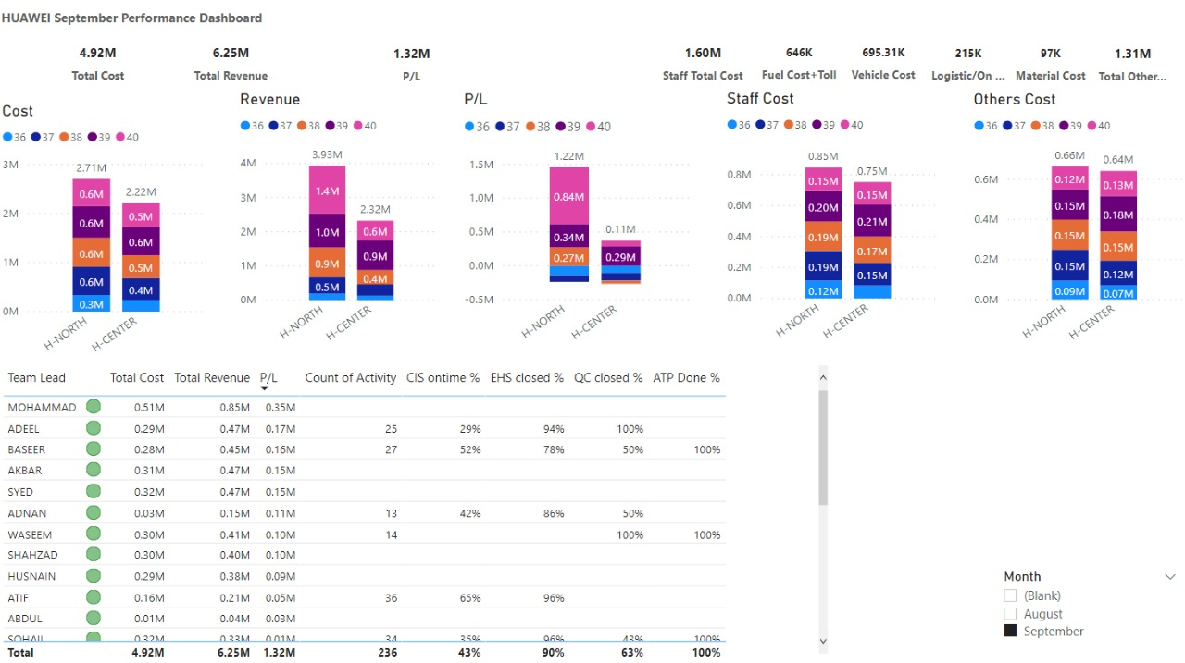

Explanation: source of data is google sheet made by me which is populated by respected KPI POCs. I load the data source into power bi and made visualizations according to instruction to my Project manager and upper management the resultant dashboard is the on going process of build and show to my upper management that spans over two months.

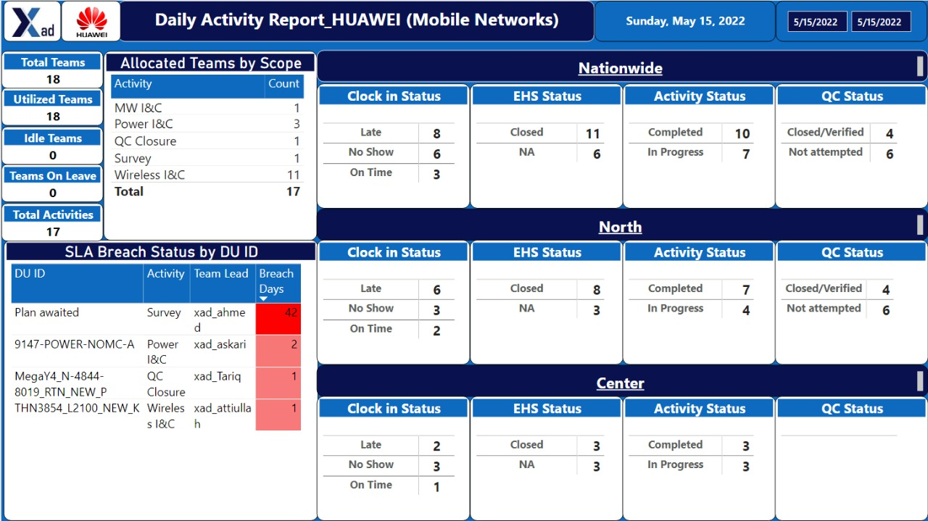

Explanation : Source data is in excel file with tables in it names salesdata, products, customers, regionalsales, Datedim. Built star schema model in power query for effective working in during analsysis and visulation stage, done some transforming and load the model in the report section of the Power BI. Built visuals using the visualization pane also use slicers for better slicing of the data.

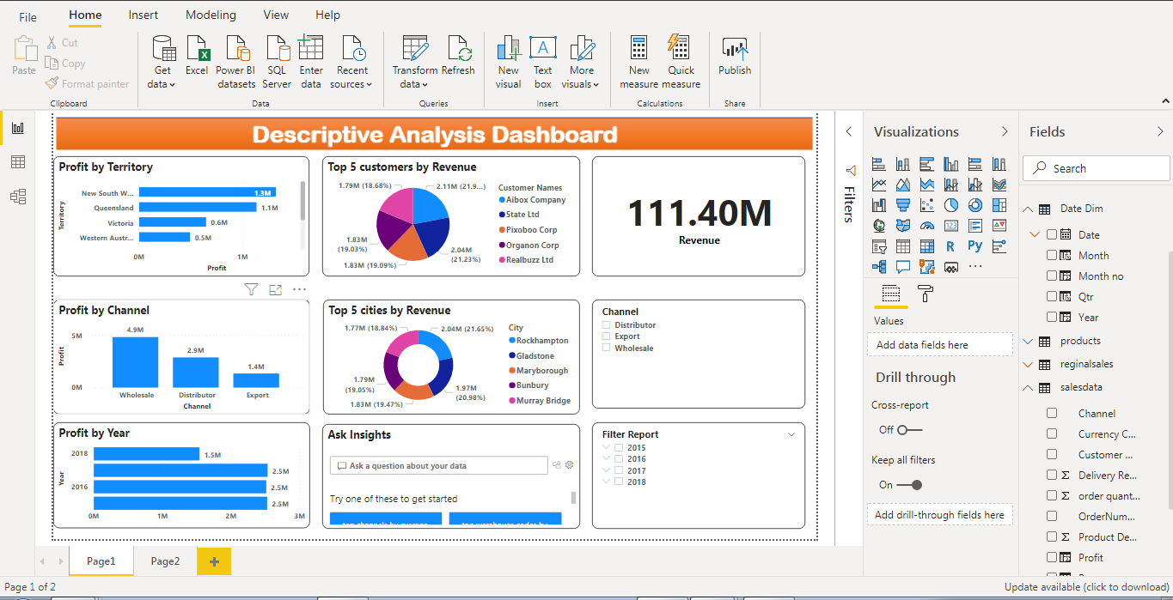

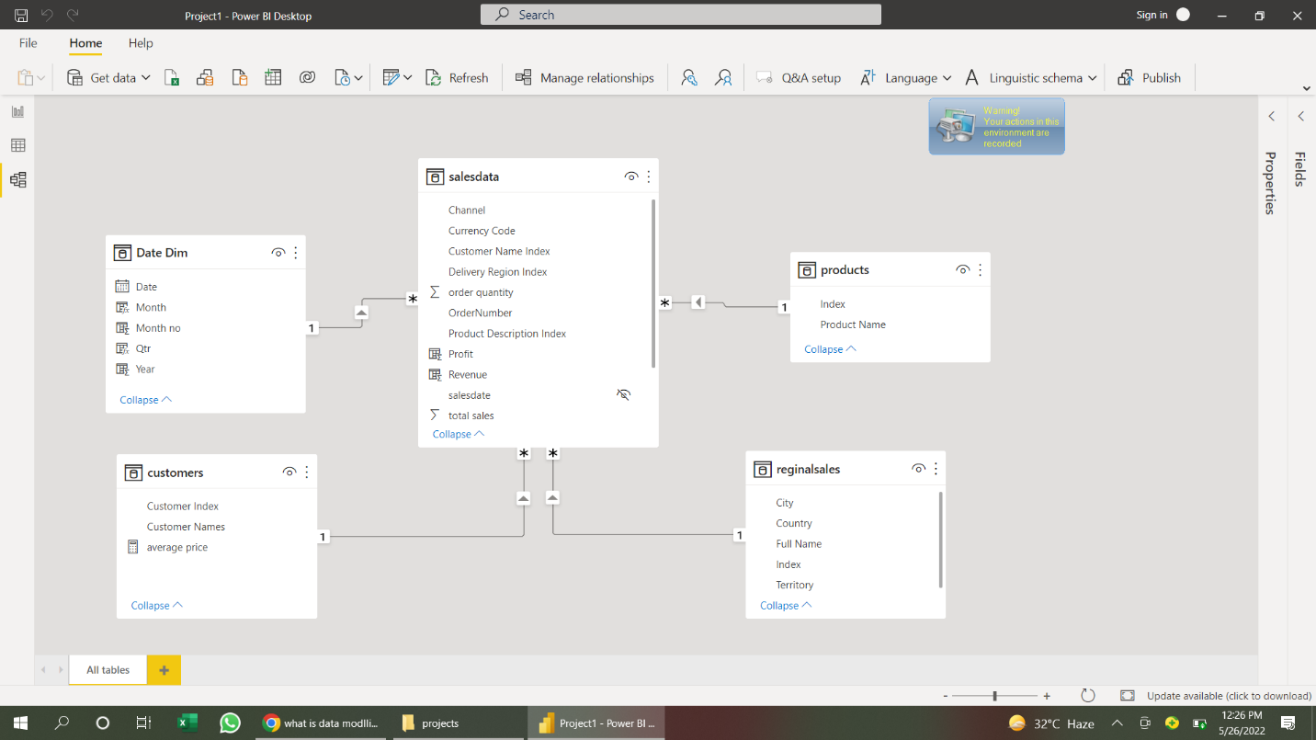

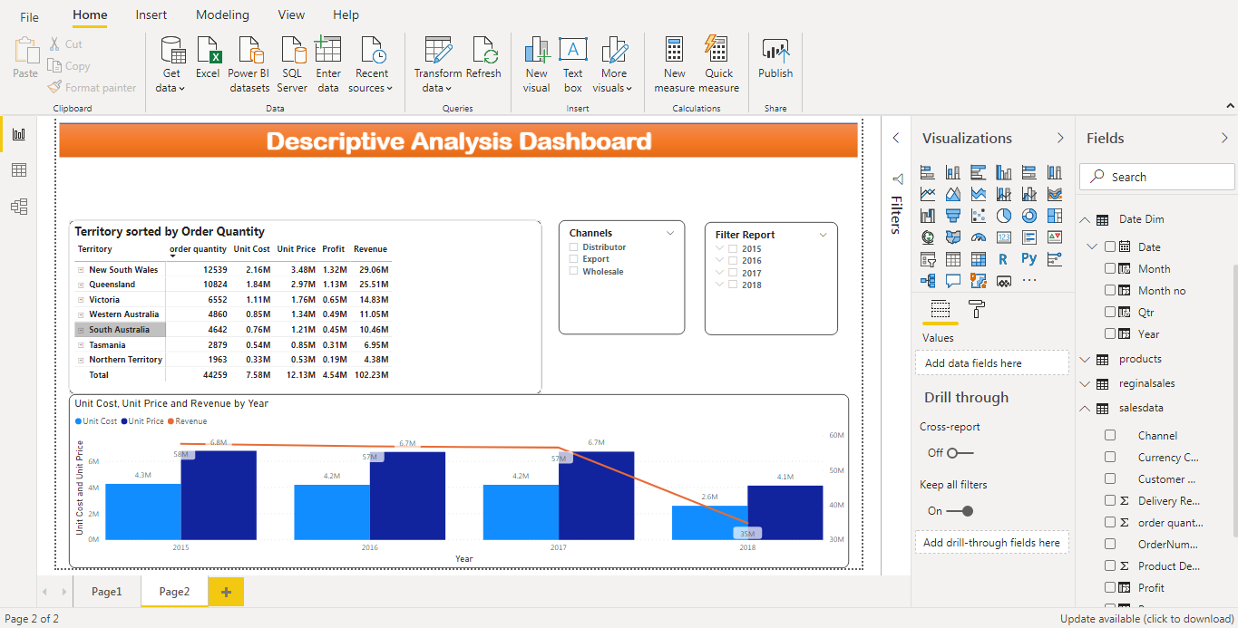

Explanantion:

Data is imported into power bi from excel dataset which has tables budget,sales and product master. I loads the data into model create new dat_dim table which consist of date,month,quarter and year using dax autocalender() function. Create measure such as current year sales,pervious year sales,YOY growth% link the new date_dim table to original dataset using star schema methodology in mind, then load the model into report view there I use visuals like cards, slicer, doughnut chart, matrix visual, line chart,scatter chart.i also use prediction in sales trends chart.

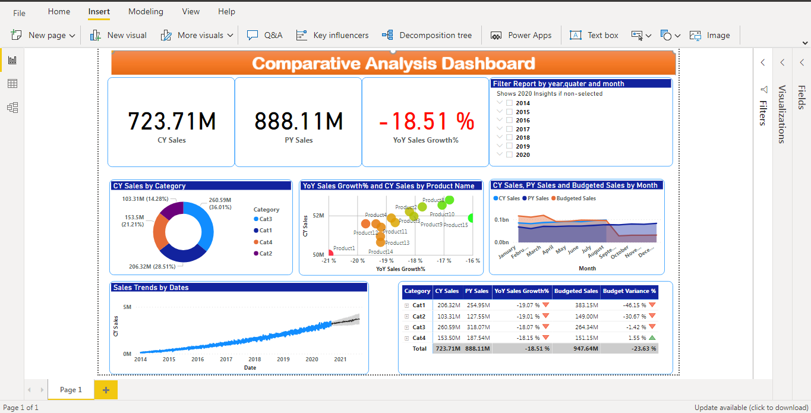

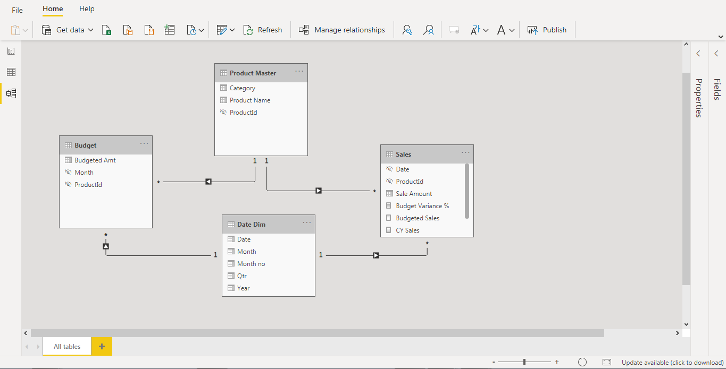

Explanataion: Data source is in excel file with tables like sales ,region I load the tables in power query editer create measure such as current year revenue,previous year revenue, YoY growth% in revenue loads the model into report view and creats visauls such as slicers,bar chart line chart with predction and scatter chart.

